**JAVA MAVEN PROJECT:**

1. **Open Eclipse**

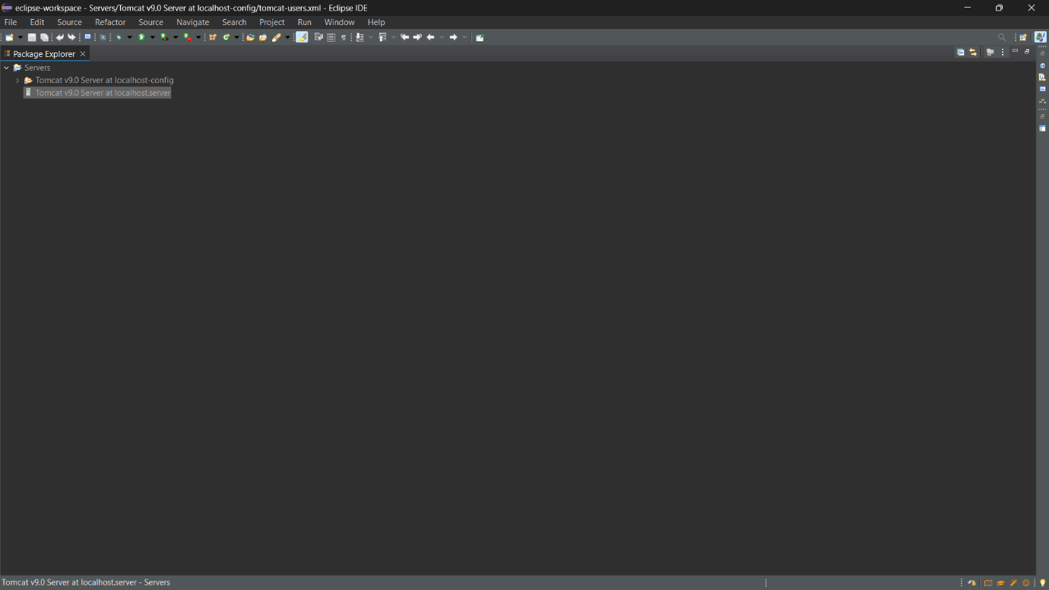

1. **Go to File->New->Maven Project**

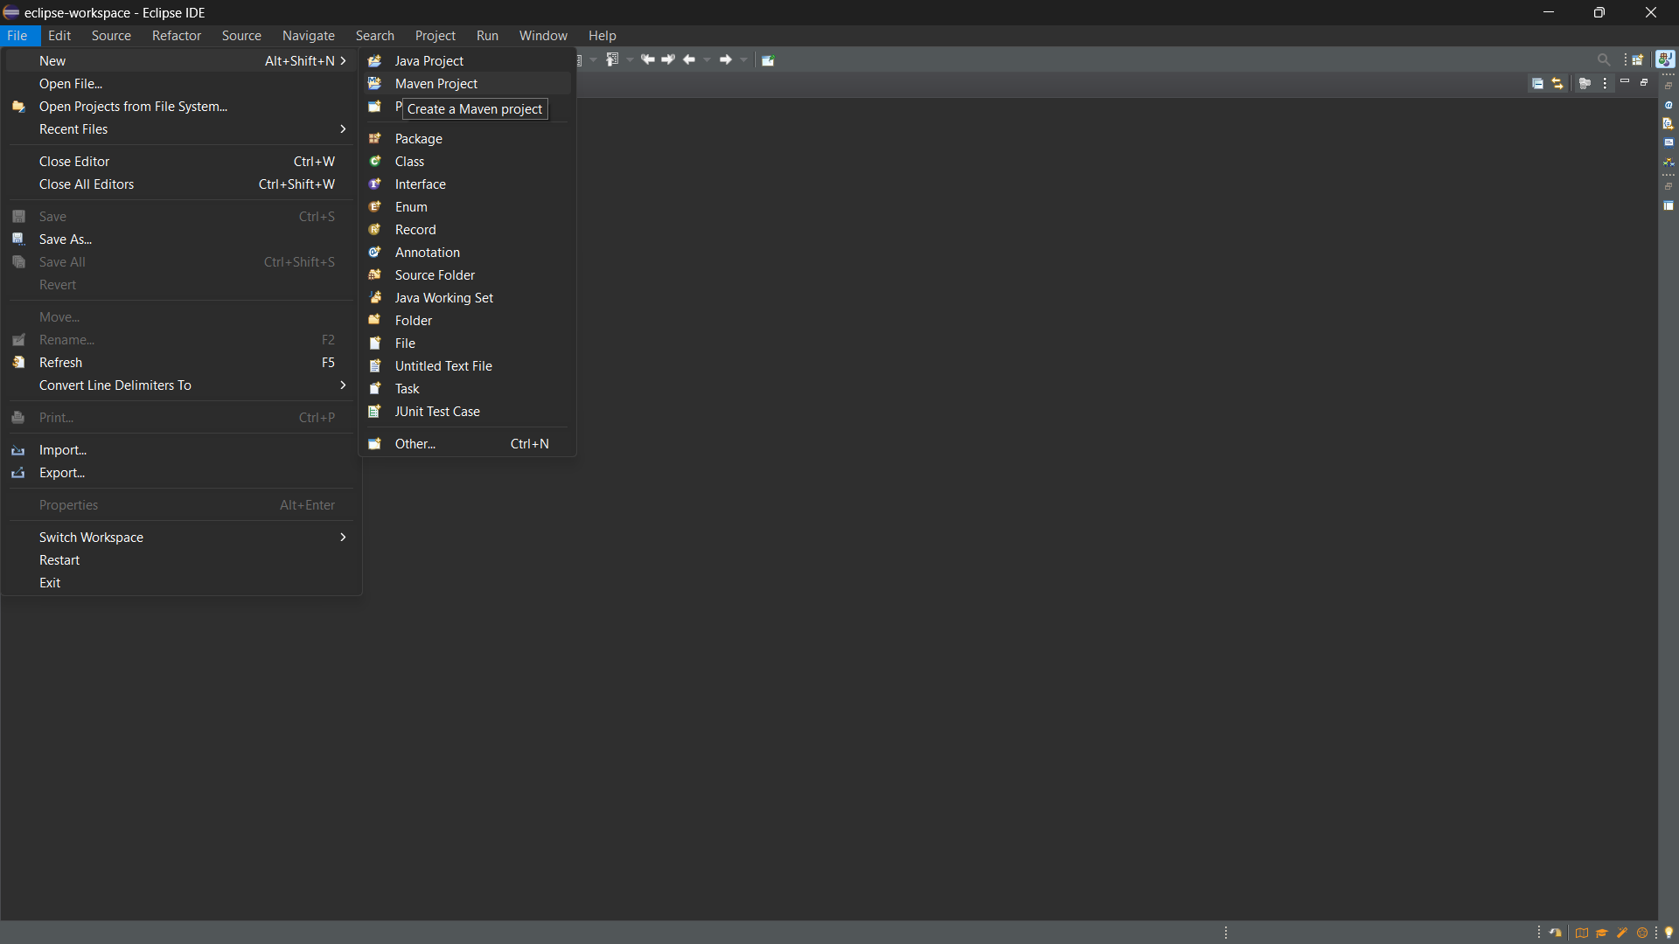

1. **Click Next**

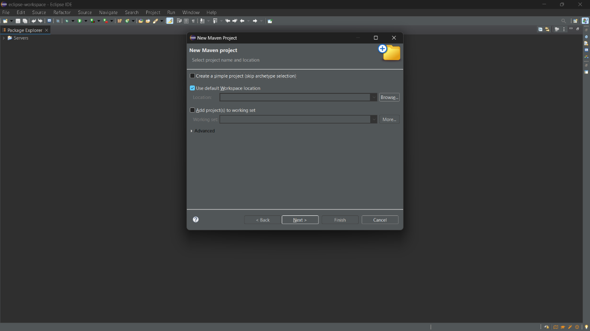

1. **In the filter option, search for org.apache.maven**

**And select the maven-archetype-quickstart**

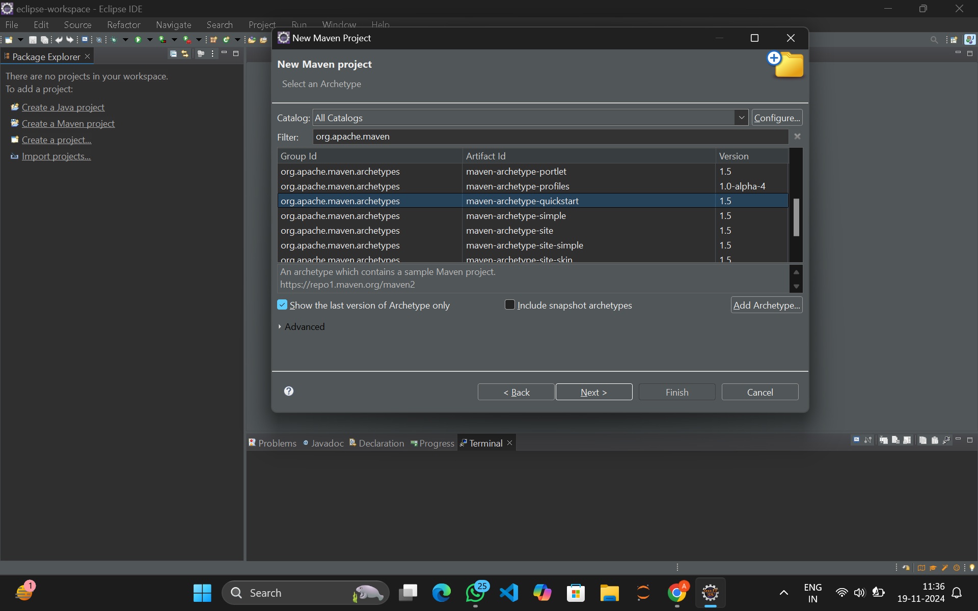

1. **Click Next and you can see the box below**

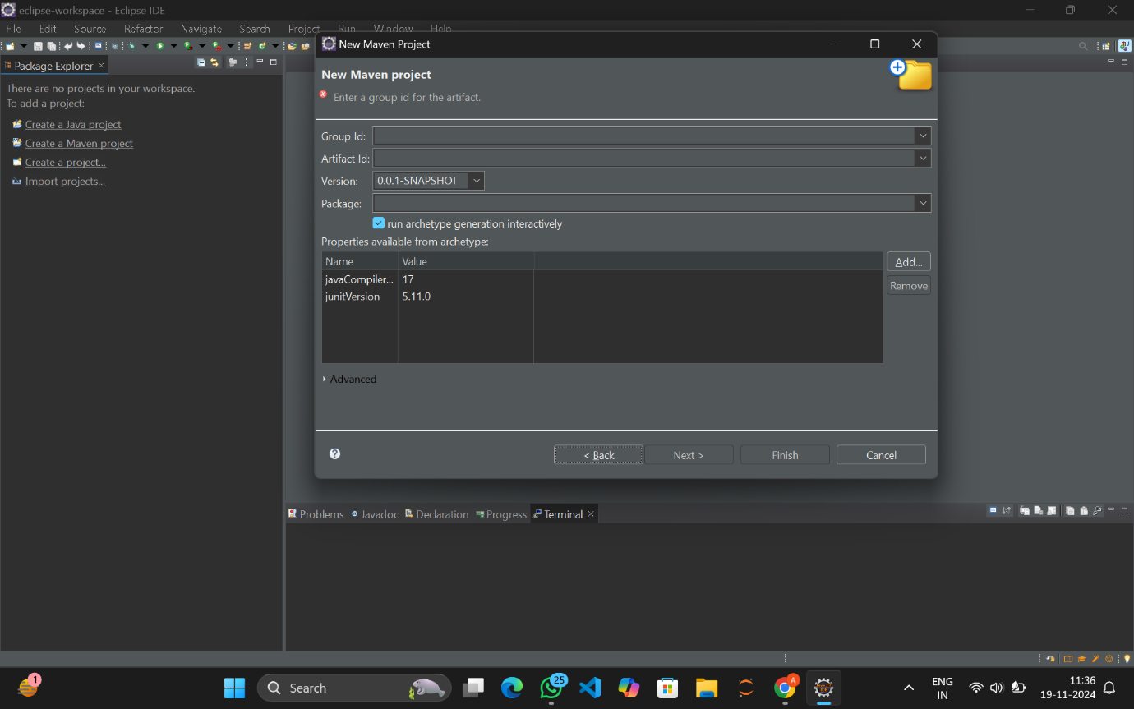

1. **Give the Group Id as com.app.demo and give the artifact Id of your choice.**

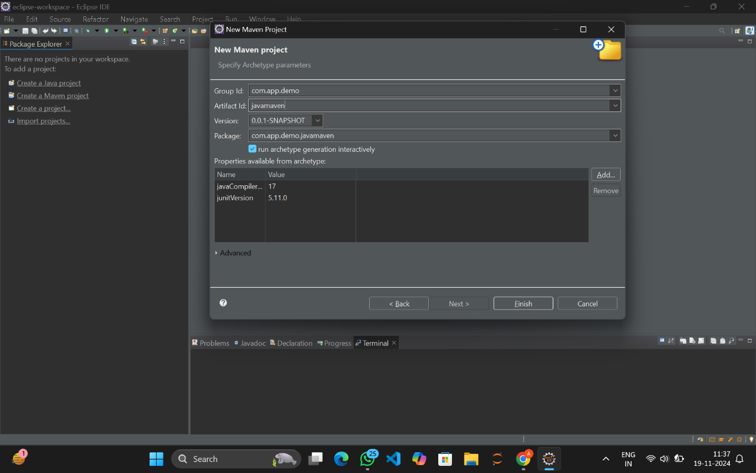

1. **Click Enter and the downloading starts.**

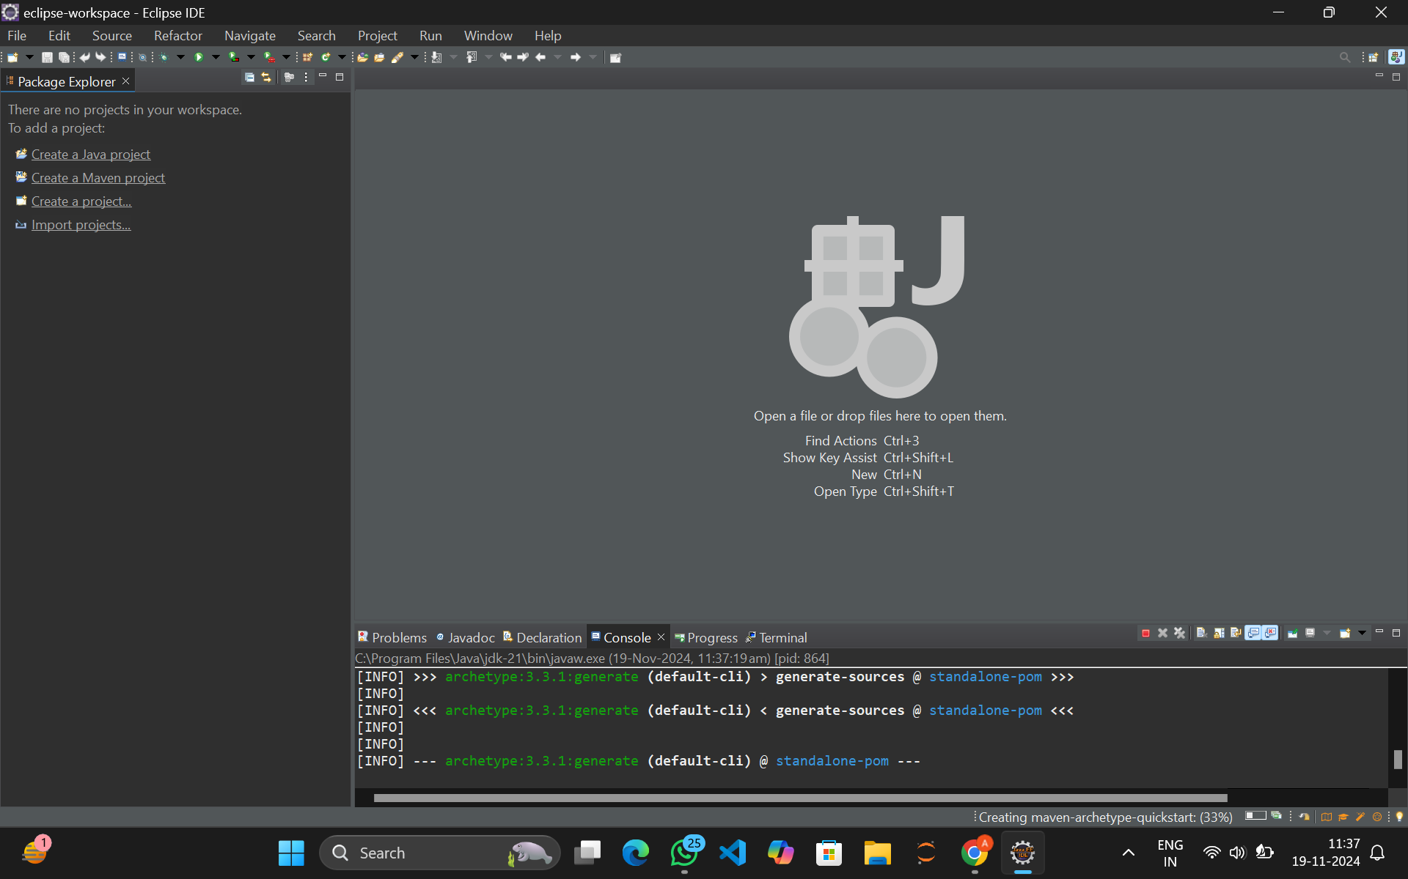

1. **You can see in the console the progress of downloads**

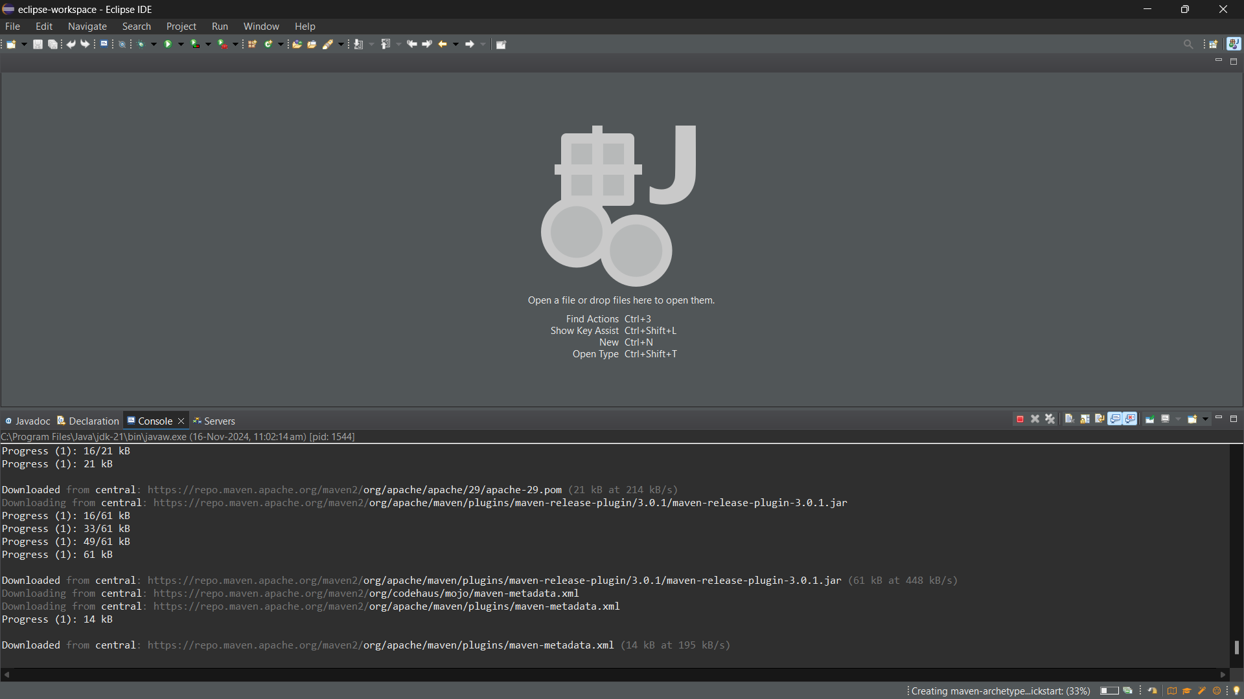

1. **The download is complete, now type Y on console.**

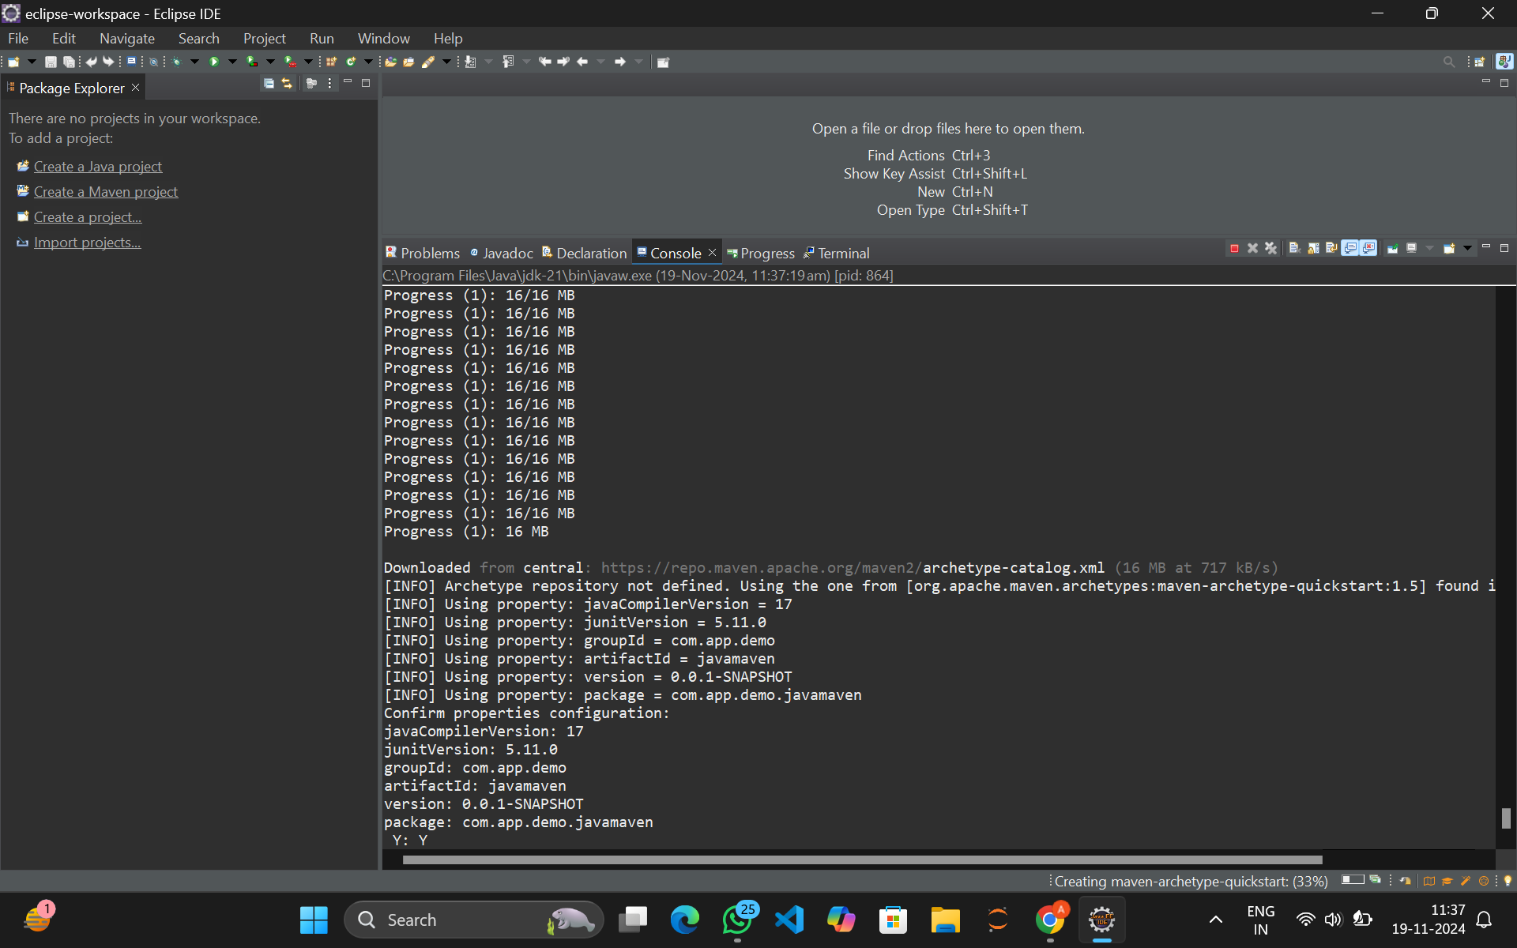

1. **The maven project build was successful.**

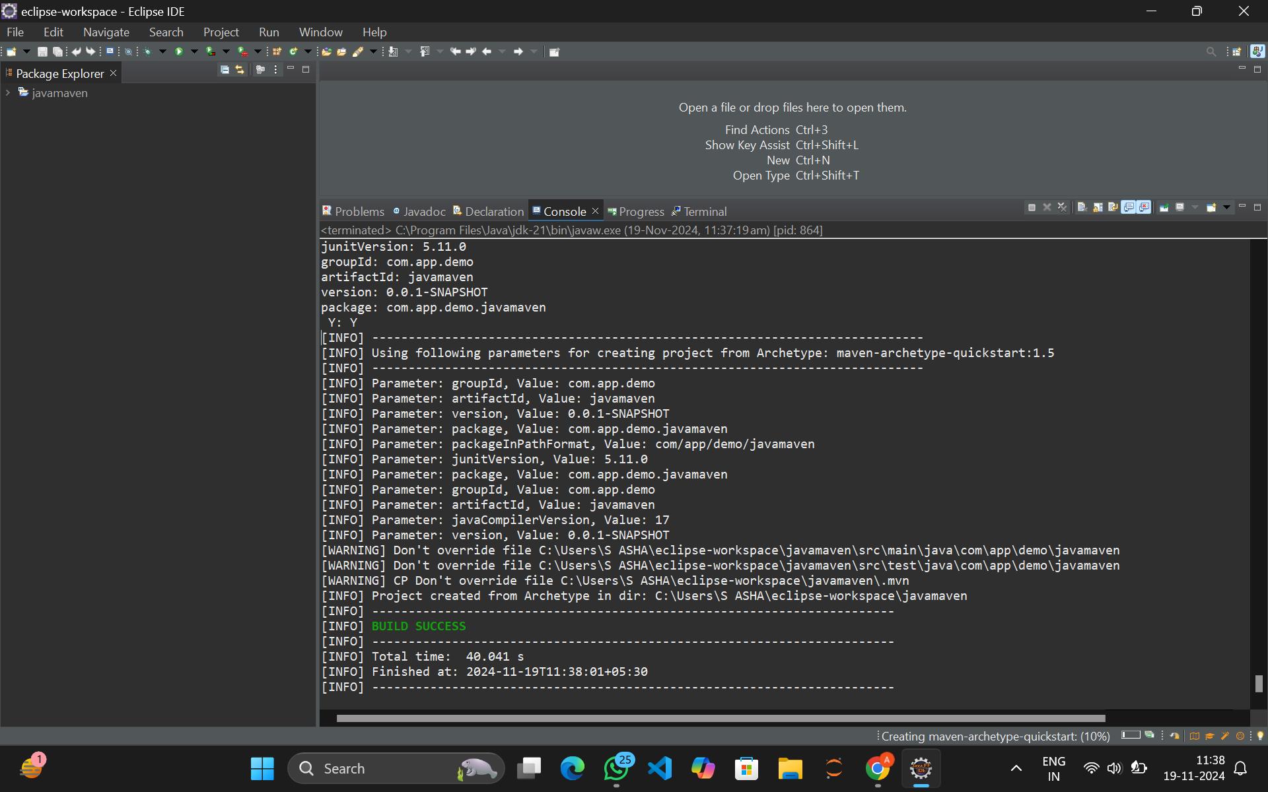

1. **You can see the project folder towards the left**



1. **Right click on the project folder and click on Run As**

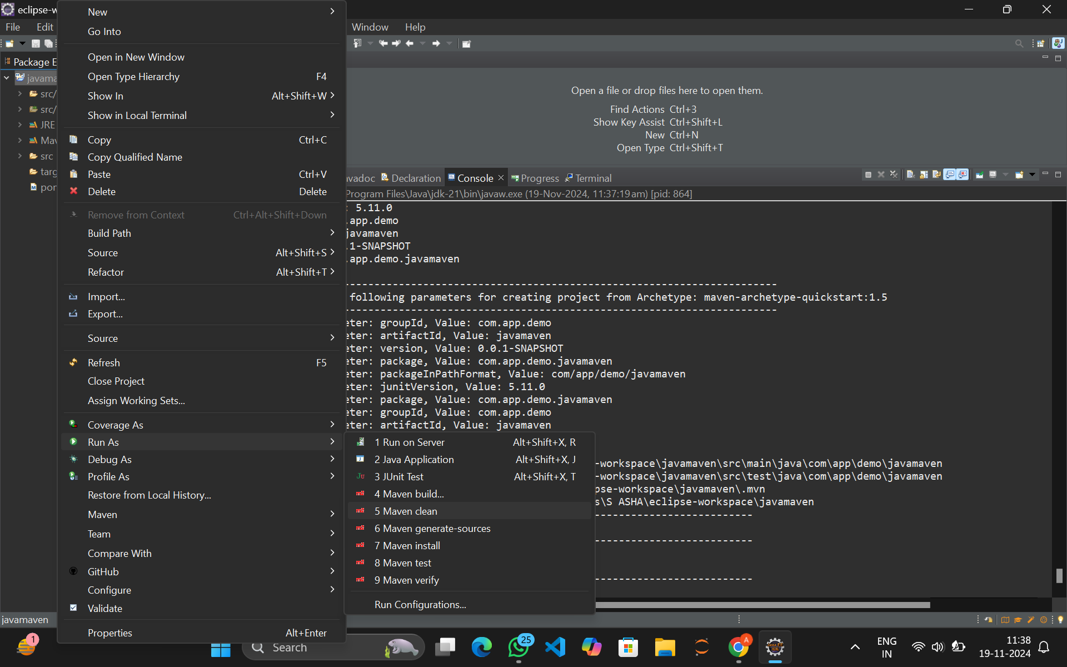

1. **Select the Maven Clean option and the process starts**

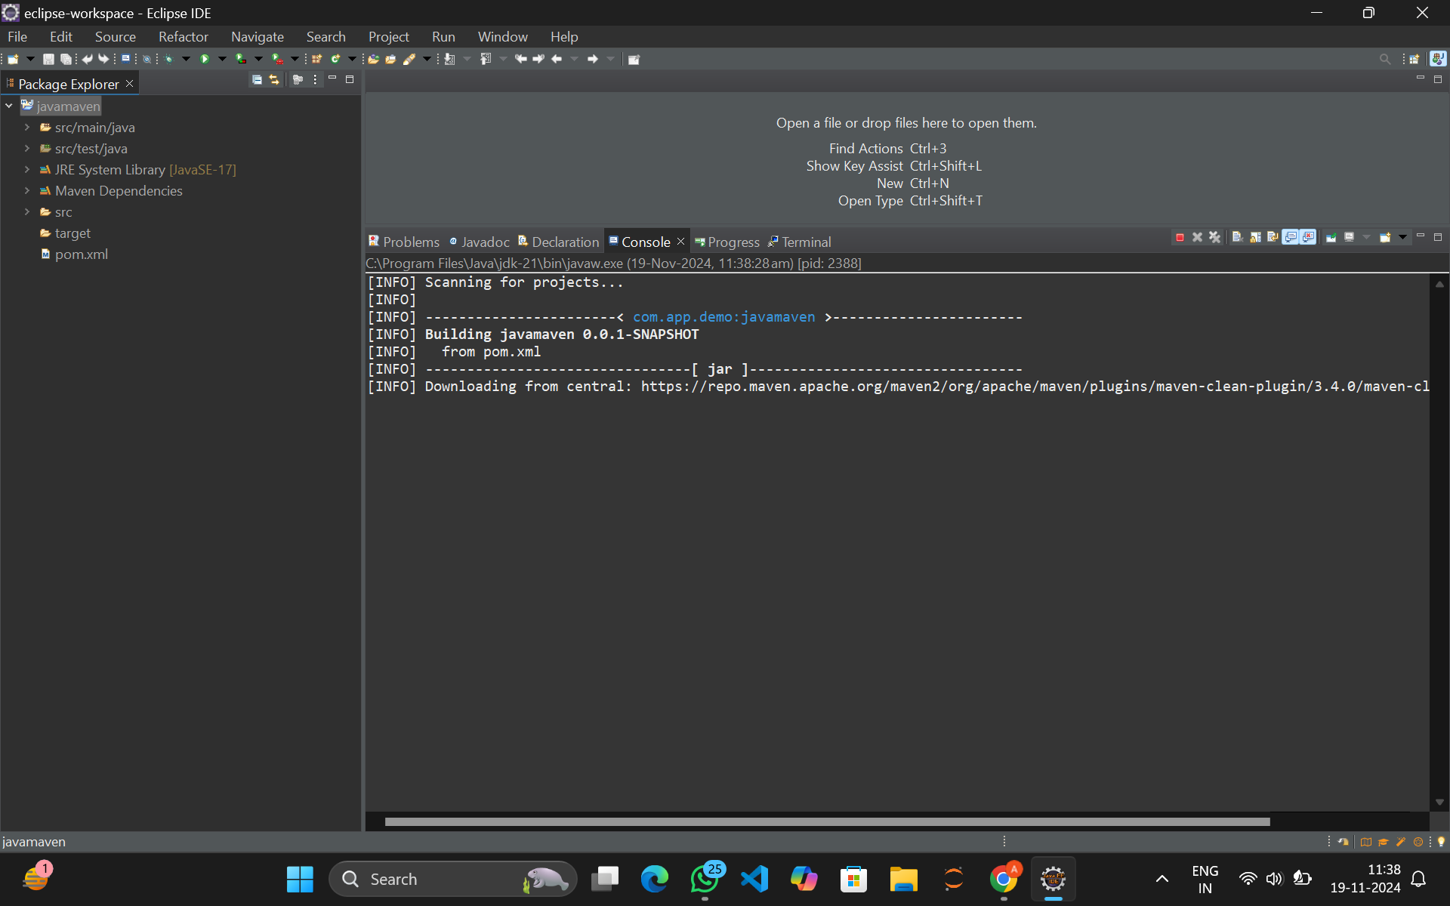

1. **The process was successful as shown below**

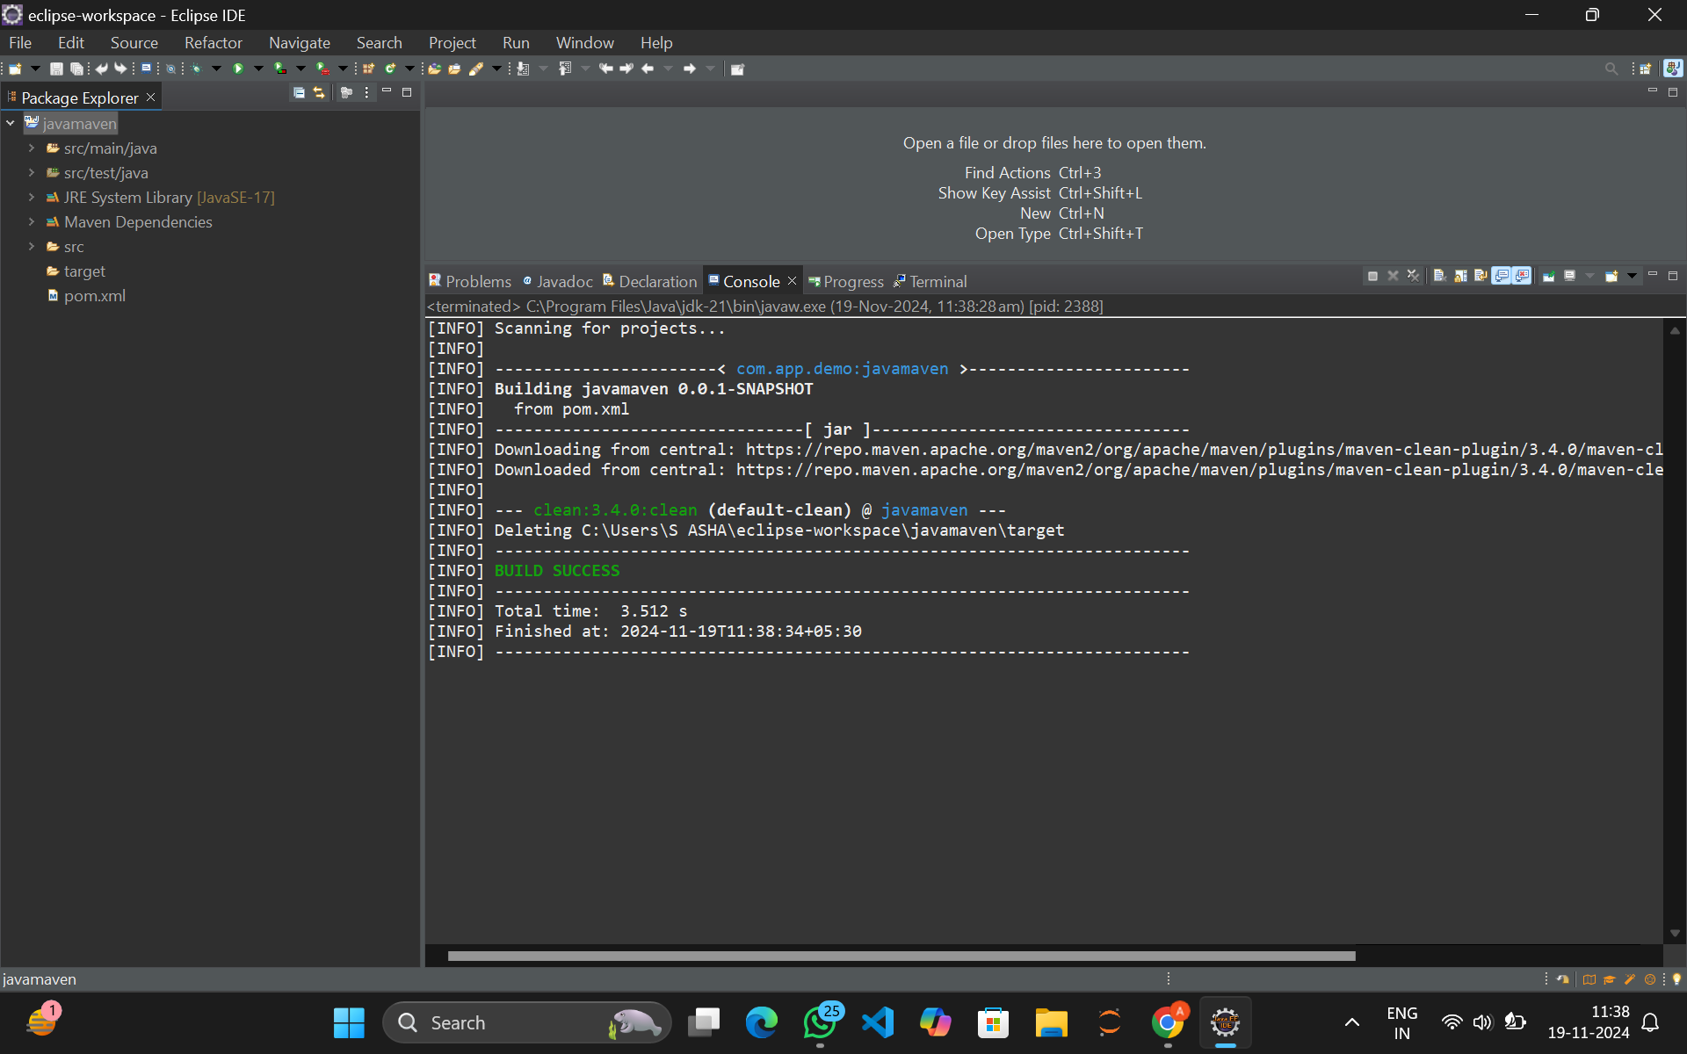

1. **Now again right click on project folder and Run As and Maven Install**

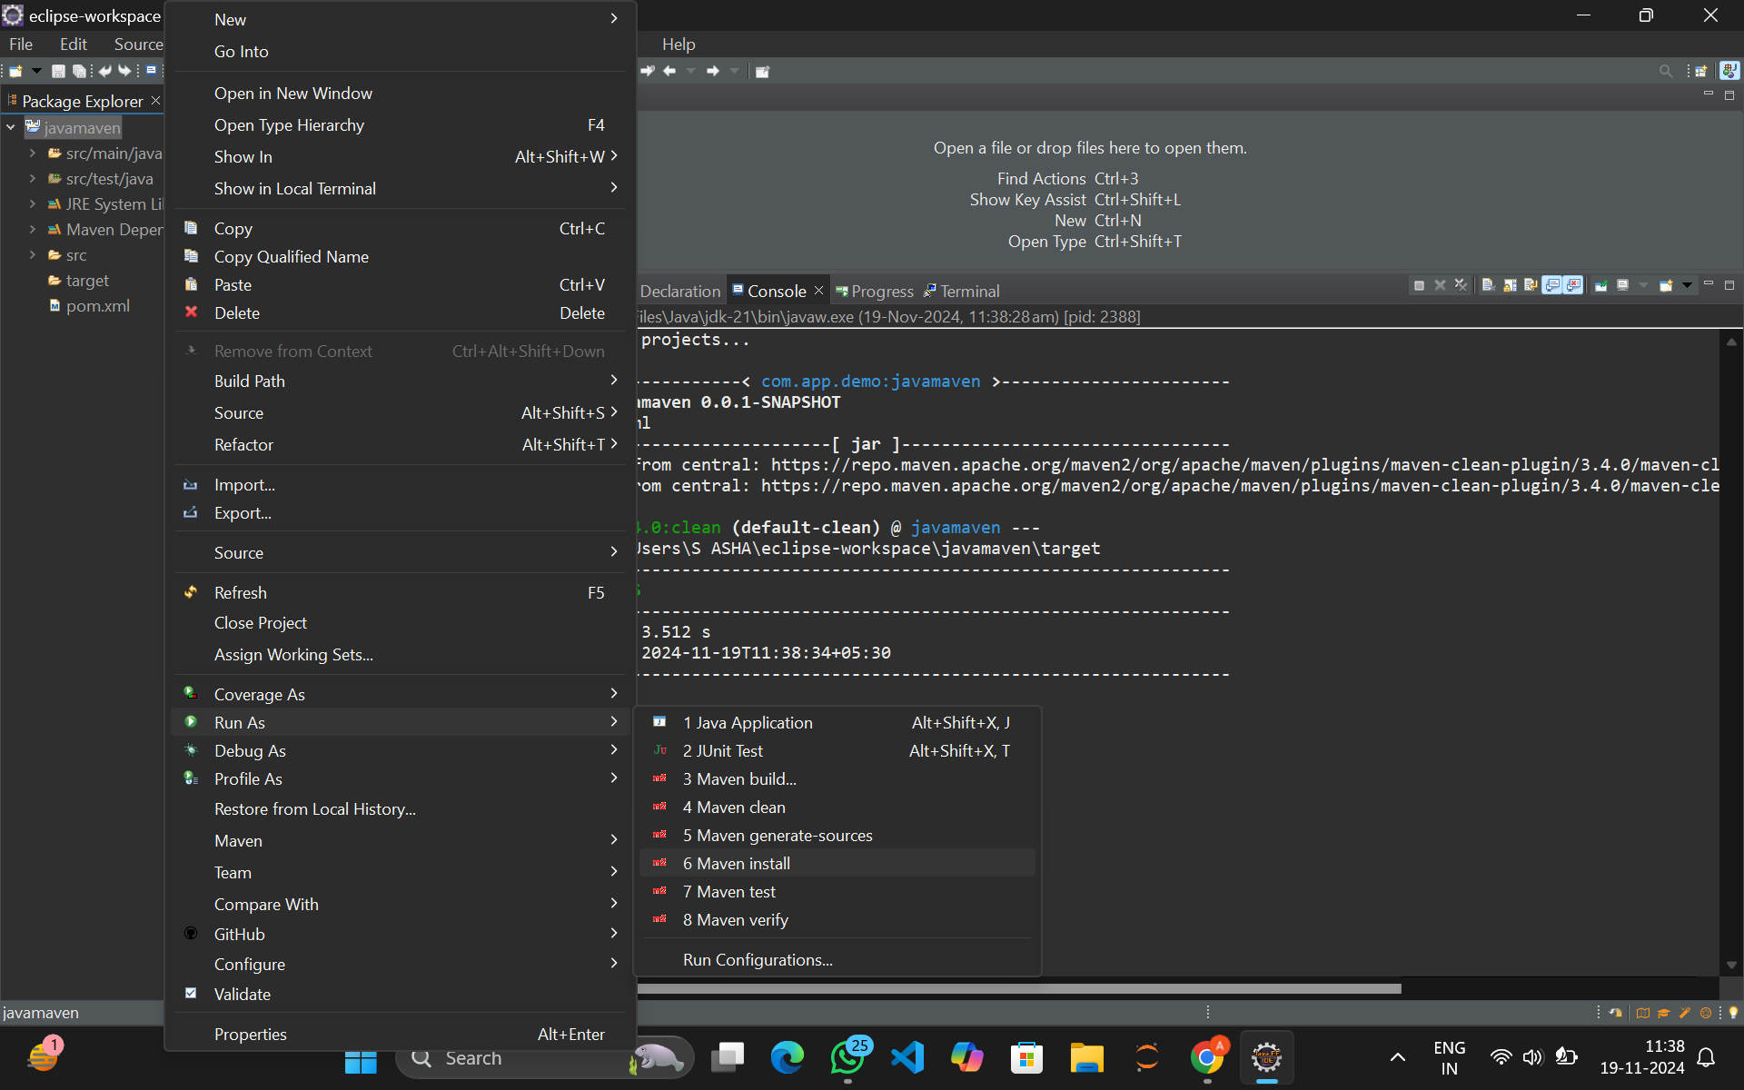

1. **It was successful as shown**

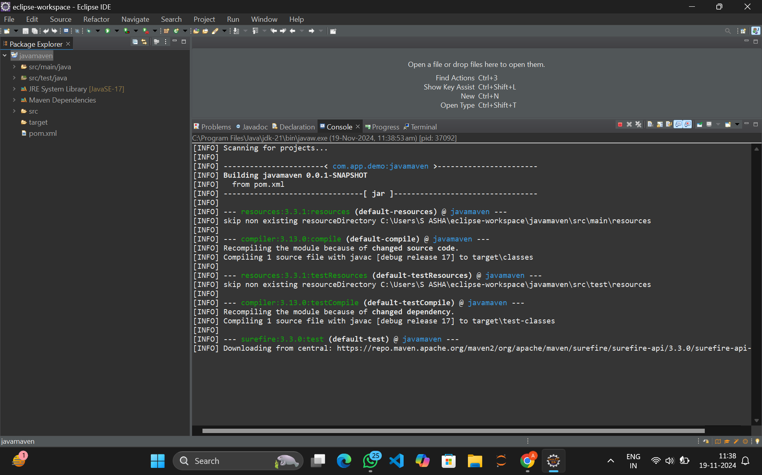

1. **Now run as maven Test**

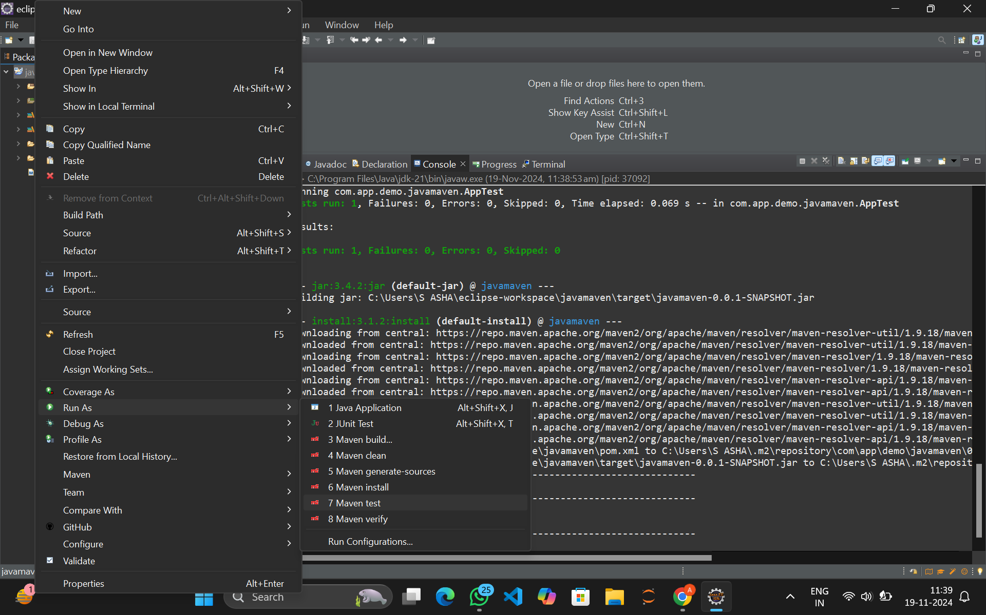

1. **The test process was successful**

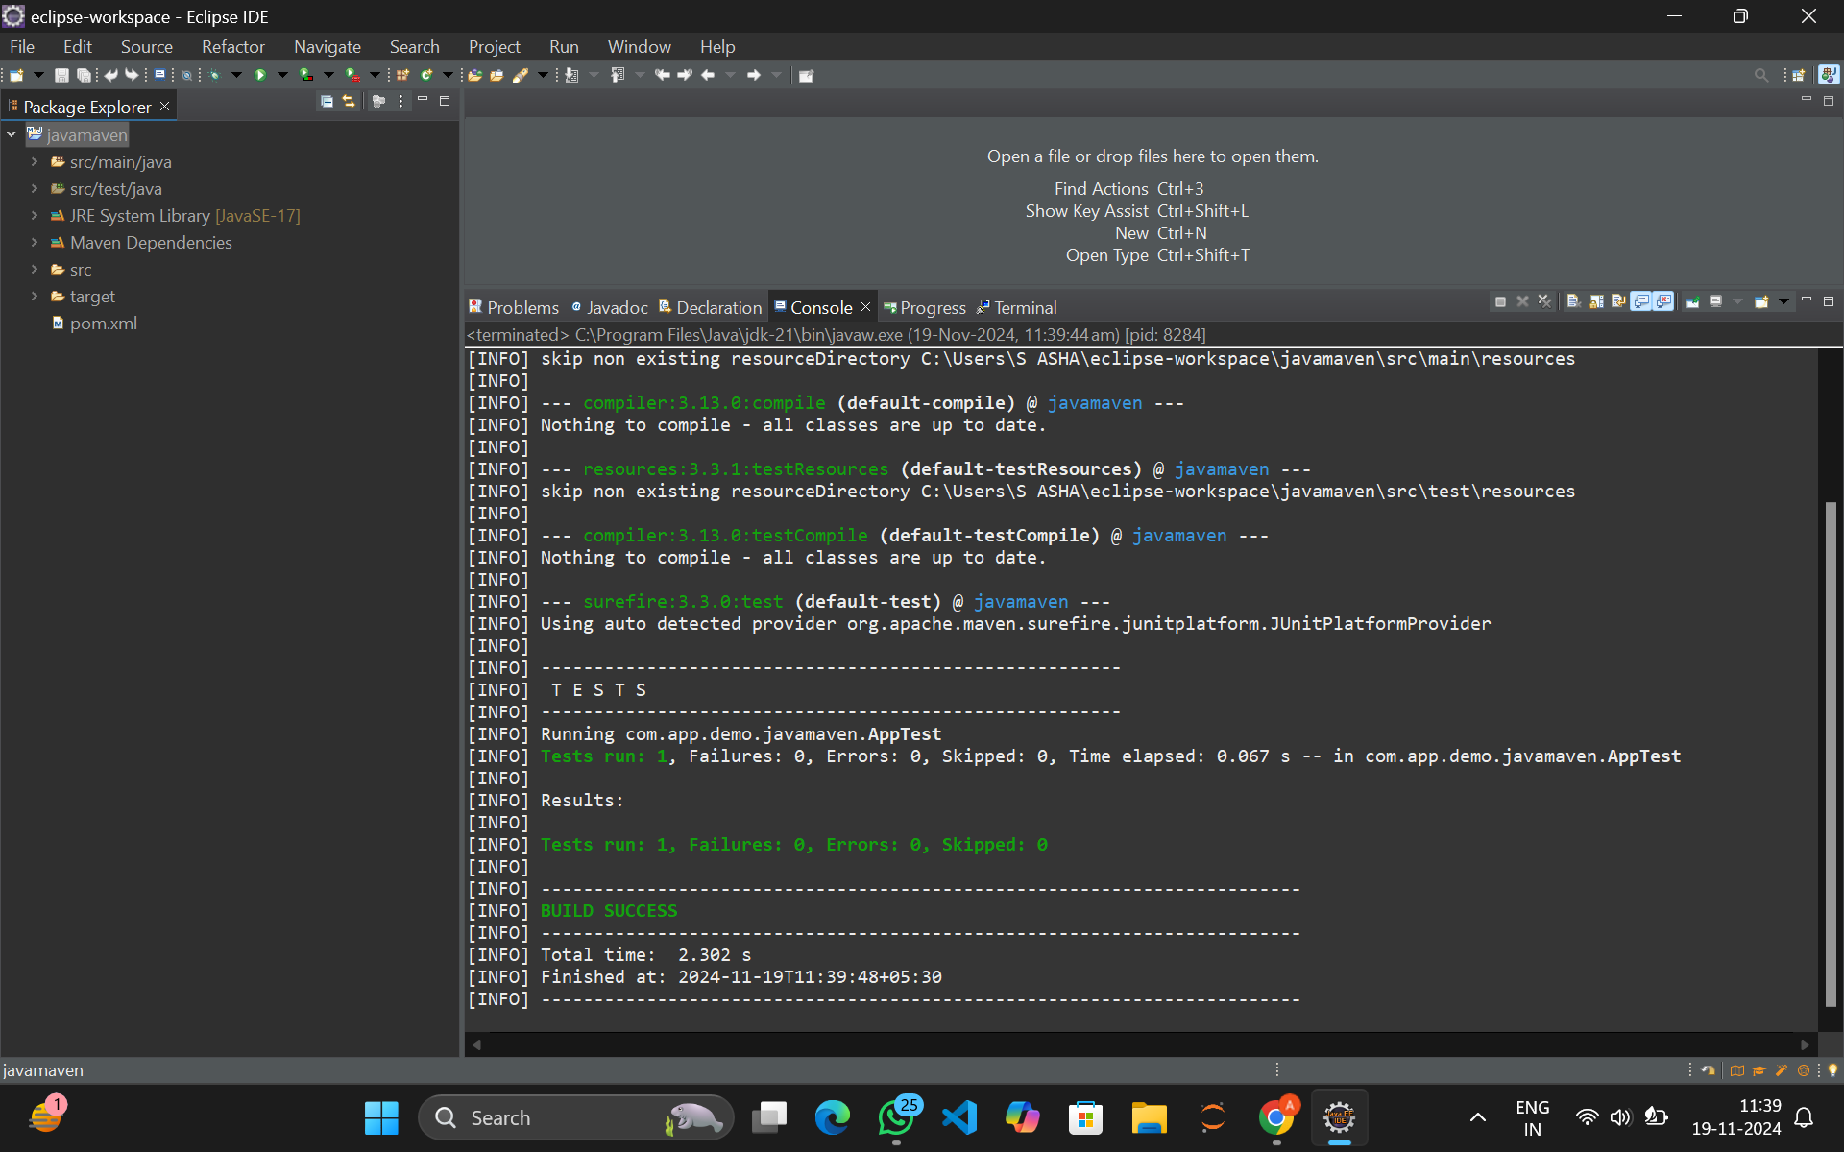

1. **Now click on Maven build**

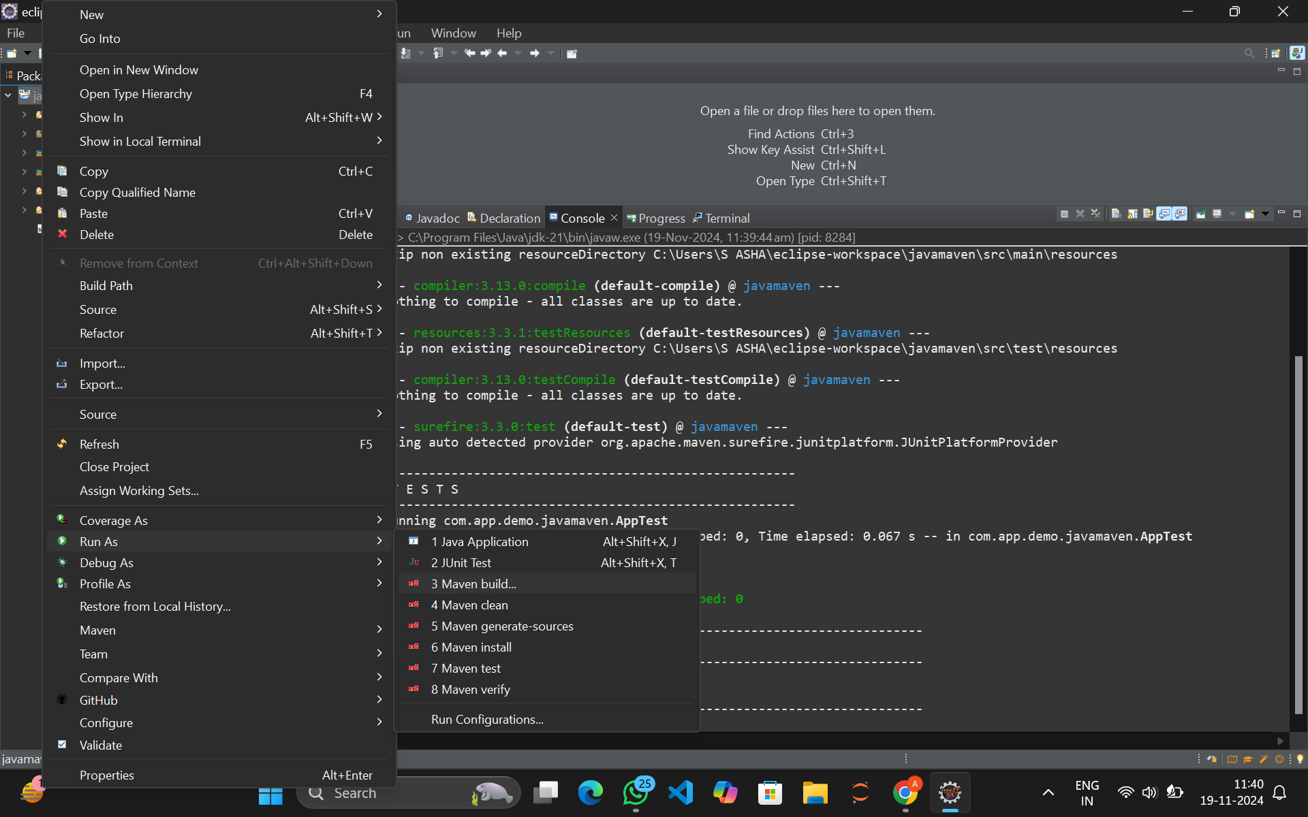

1. **In the configurations goals type Clean test install**

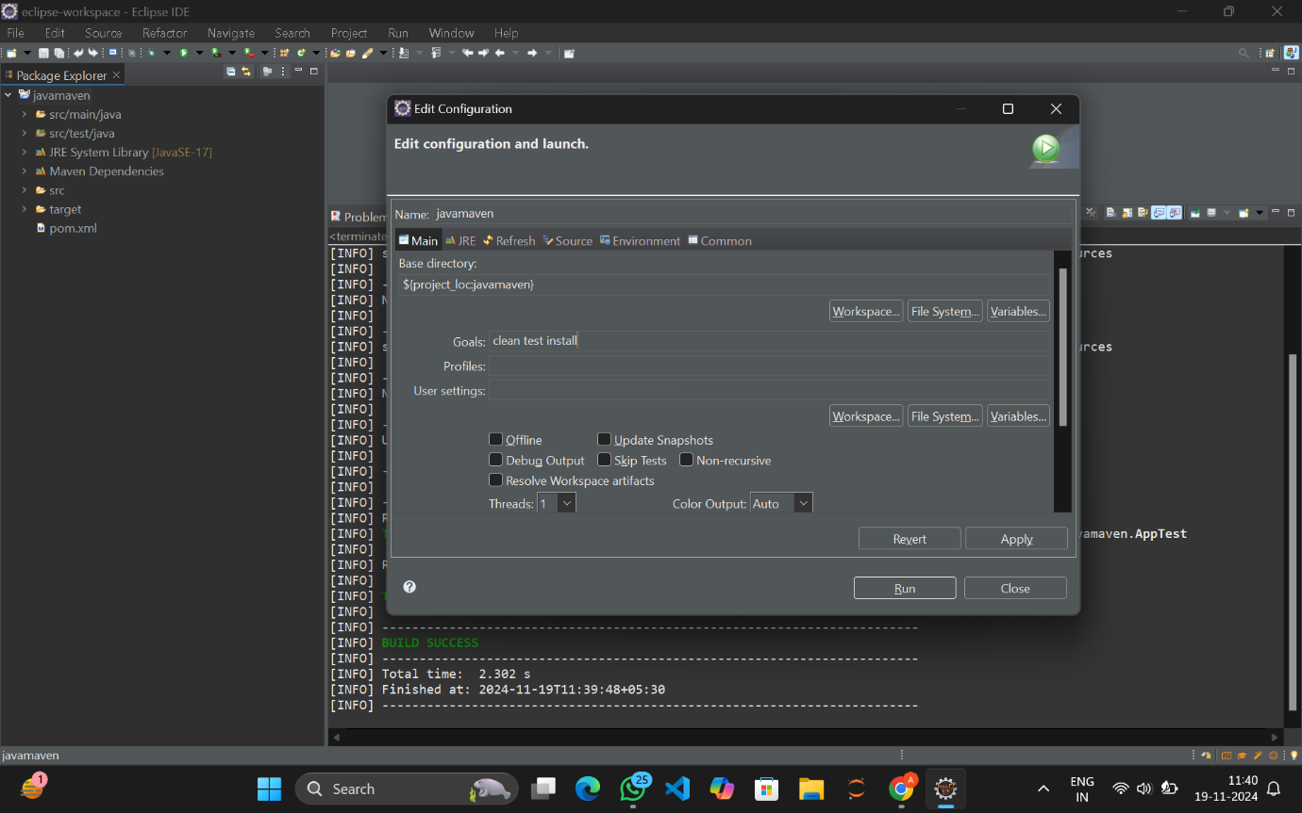

1. **Click on run**



1. **The build was successful**

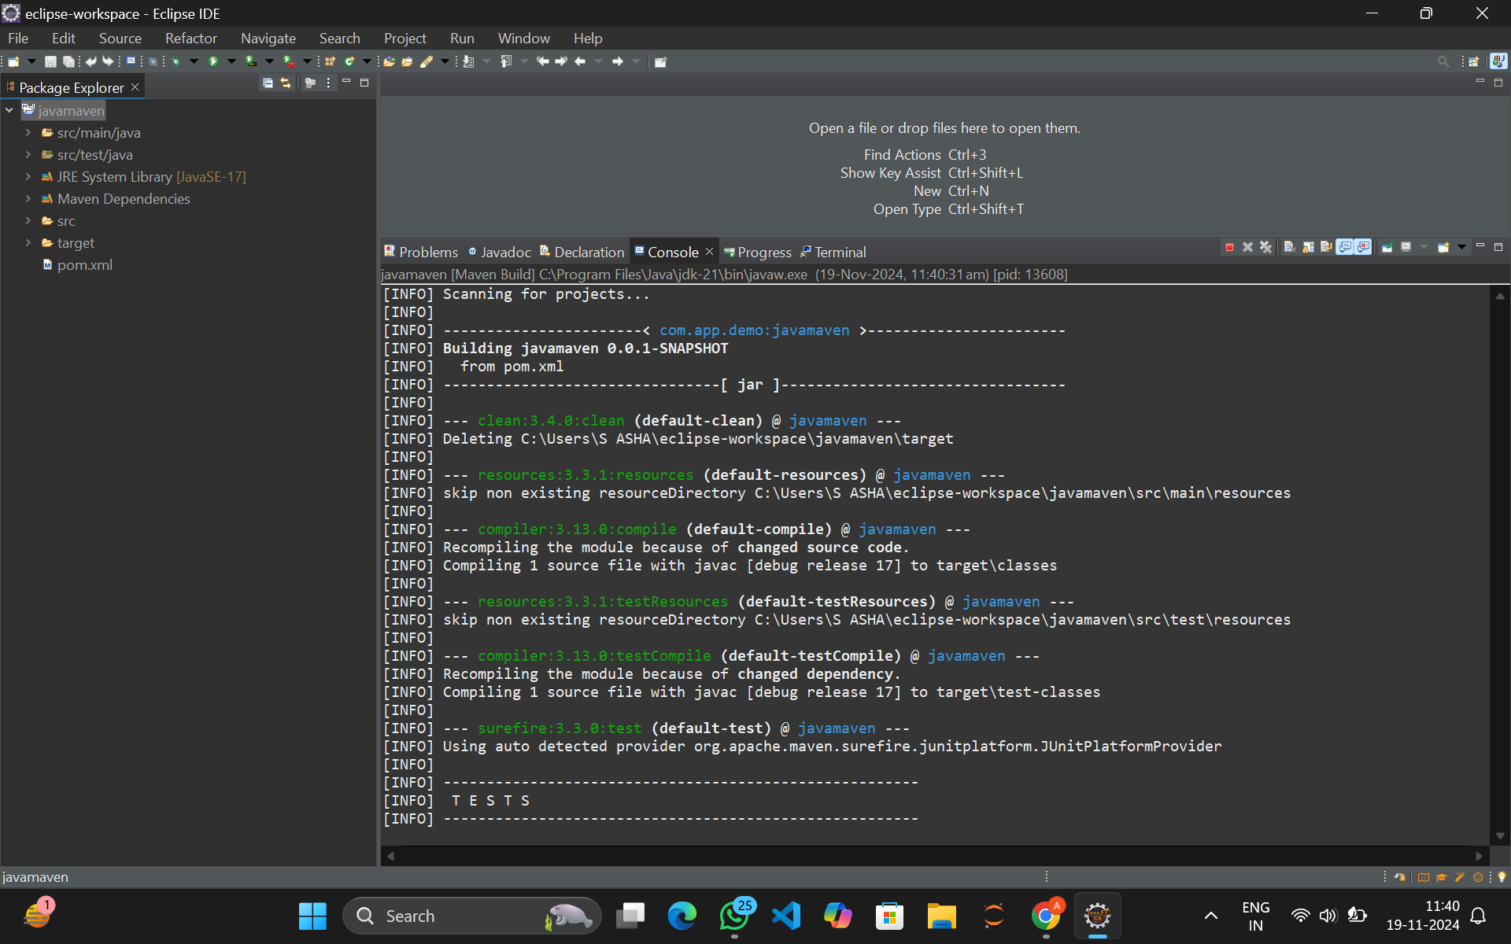

1. **Now Run as Java application**

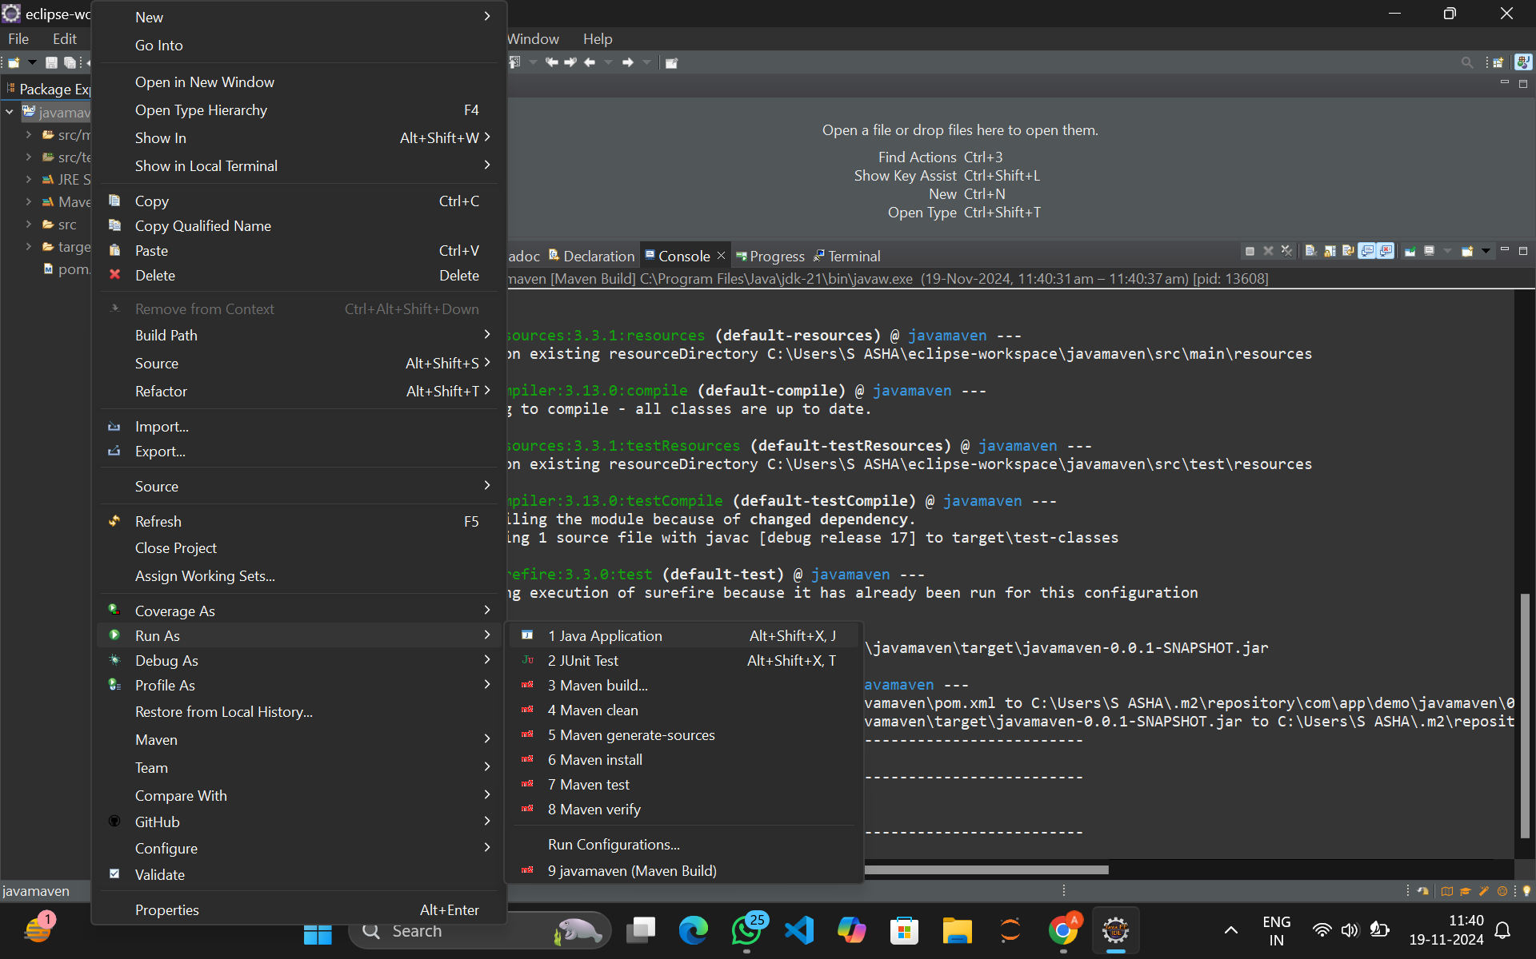

1. **In the console you can see the Hello World message**

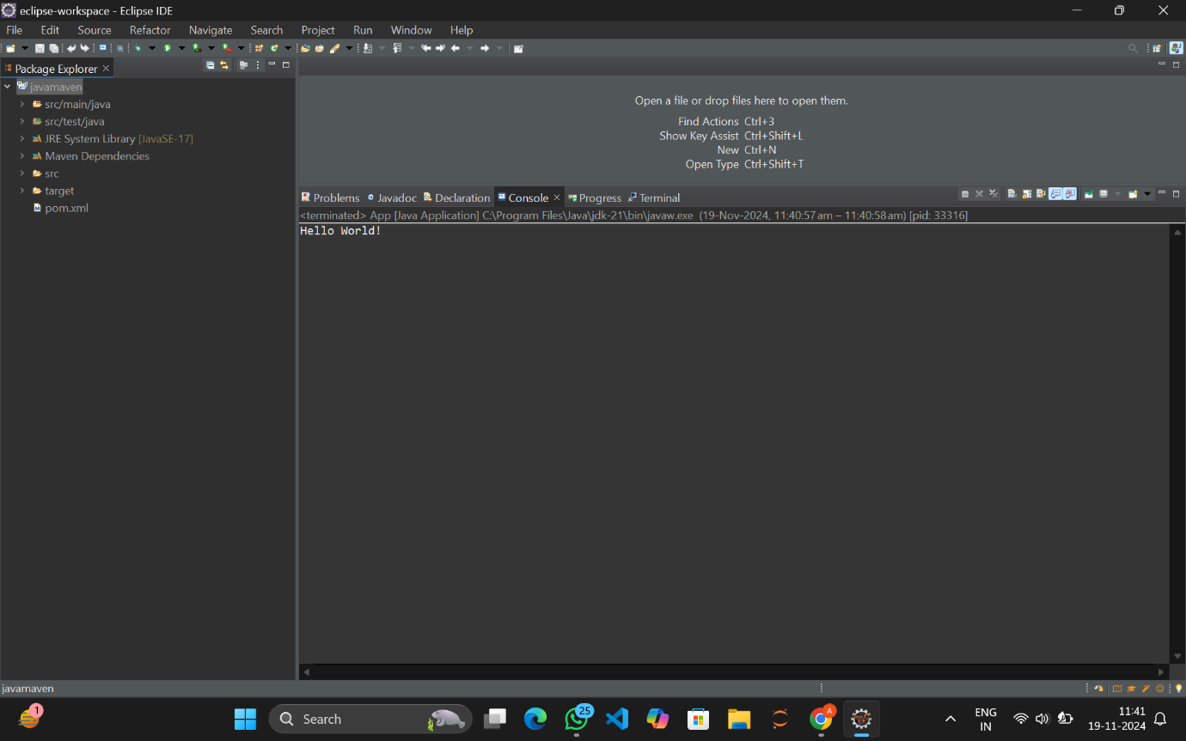

1. **Right click on the project folder ,select show in local terminal and click Git bash**

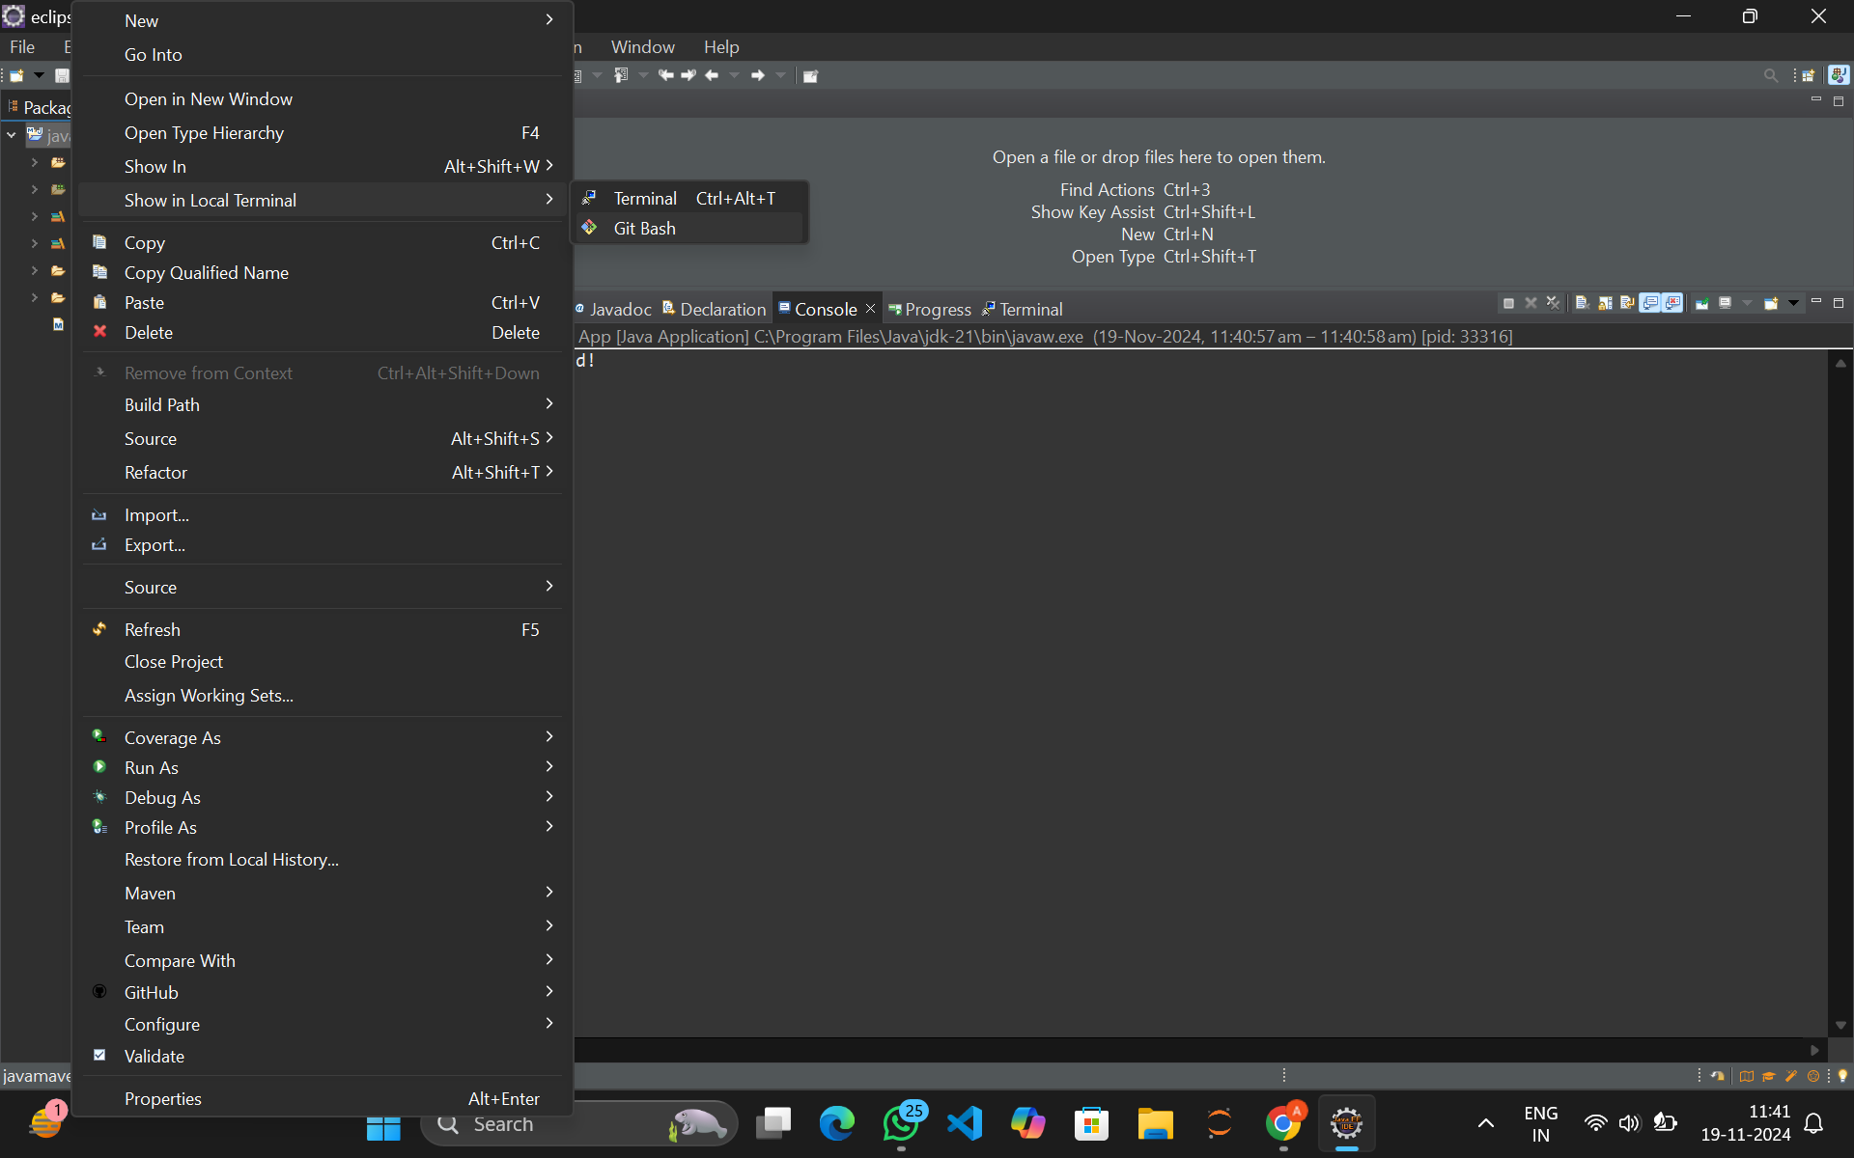

1. **Git Bash terminal is opened**

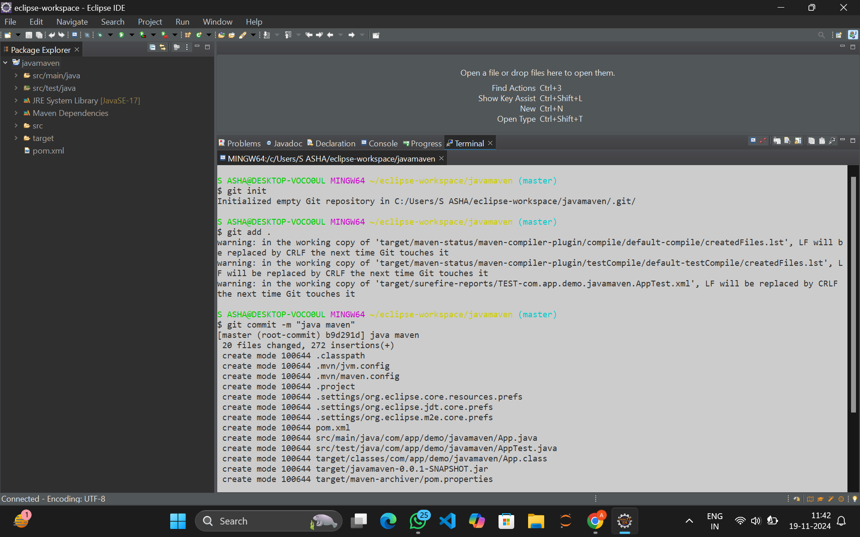

1. **Initialize Git by using git init command**



1. **Add the files using git add .**

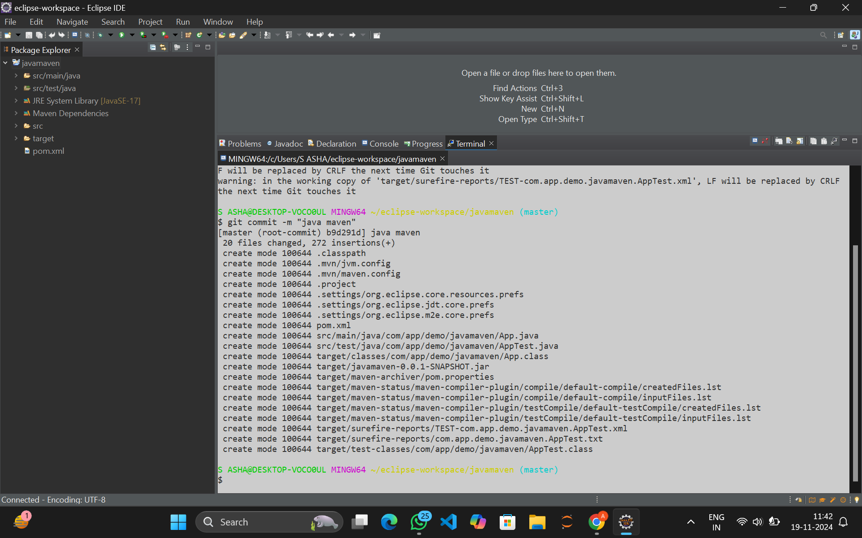

1. **Commit the changes**



1. **The commit is done**



1. **Now add the remote repository using remote add origin command**
2. **And also use the push command to push changes**

v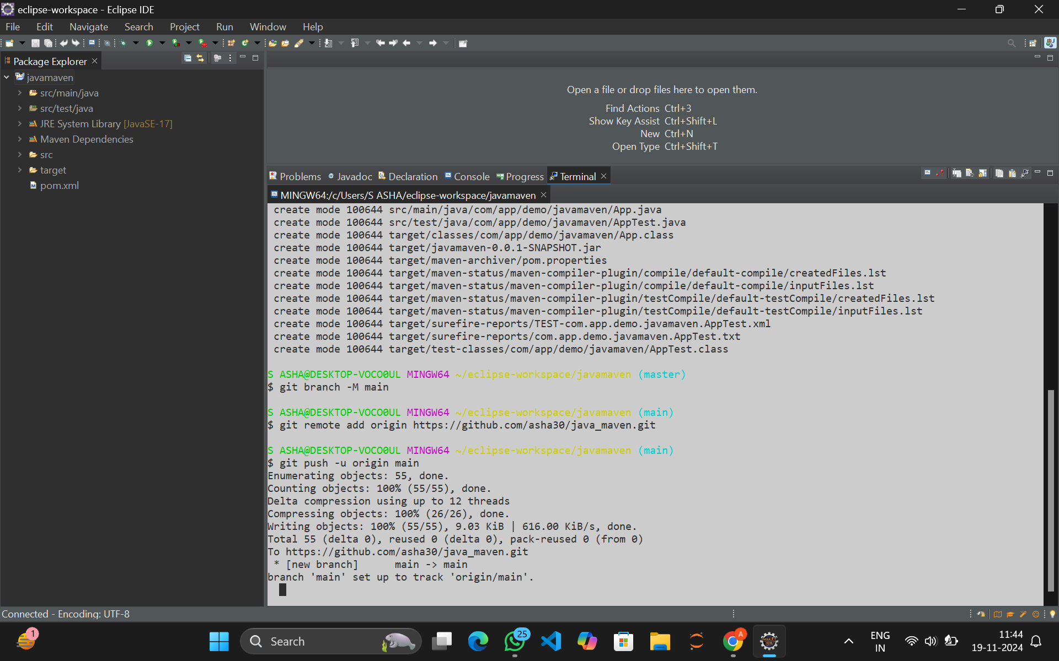**You can see the pushed changes on the github account repository**

